The
Flavored
Fork
RUSTIC. ITALIAN

(772) 985-1221 chefmatt@theflavoredfork.com

Choose any 3 pizzas cooked fresh onsite (subject to venue & location of grill placement)
Includes high quality disposable acrylic plates, napkins, flatware.

Wood Fired Pizza Catering Menu

Must be able to park Pizza oven within reasonable walking distance of buffet. Preferably right next to it for best experience.
Parties of 25 or less minimum $500 for 1 hour of unlimited pizza - after hours $750.
Pizza Packages - min 50 people or $800 Pizzaria Uno –
Includes pizza and Salad approximately 75 minutes
includes Americana - house plum tomato sauce & shredded mozzarella Pepperoni Pizza or Margherita.
Pizza- Fresh Mozzarella & Fresh Torn Basil - Caesar or House salad - $16.25pp
Pizza Festa (party) - min 50 people or $1025- unlimited pizza - 1 1/2 hours
includes Americana - house plum tomato sauce & shredded mozzarella / Pepperoni pizza / Margherita Pizza - fresh mozzarella & fresh torn basil
Specialty Pizza – 3 options available and includes, Caesar or House salad $20.50pp
Pasto Della Pizza (pizza meal) - min 50 people or $1250 unlimited pizza - 2 hours
Starter - Antipasto platter - includes Americana - house plum tomato sauce & shredded mozzarella / Pepperoni pizza / Margherita Pizza - fresh mozzarella & fresh torn basil - 3 specialty pizza options - choice of 2 meatballs or 3 wood fired wings pp - Caesar or House salad. $25 pp

GLUTEN FREE CRUST & DAIRY FREE CHEESE AVAILABLE
OPTIONAL ADD-ONS
ADD THESE ON TO YOUR PIZZA PACKAGE. PRICED PER PERSON. Based on parties of 50+
Pasta Entrees (Baked ziti, penne w/ choice of alla vodka, Alfredo, pesto cream sauce, sun-dried tomato cream sauce, fra diavolo🌶)- starting at $3.50pp (without meat) + meats such as sliced meatballs, sausage, grilled chicken, grilled or poached shrimp, seafood medley.
Pasta Action station (we cook in front of guests) - starting at $5p add Flaming 36 month aged Parmigiano Reggiano cheese wheel $5 additional (includes shaved parmesan)
Fire Roasted Meatballs $4.00 Marinara Sauce
Wood Fired Wings $4.00 (approximately 3 pp)
Limoncello Rosemary marinade or lemon pepper & garlic sauce
Fire Roasted Asparagus $4.50
Lemon Zest, Extra Virgin Olive Oil, Sea Salt
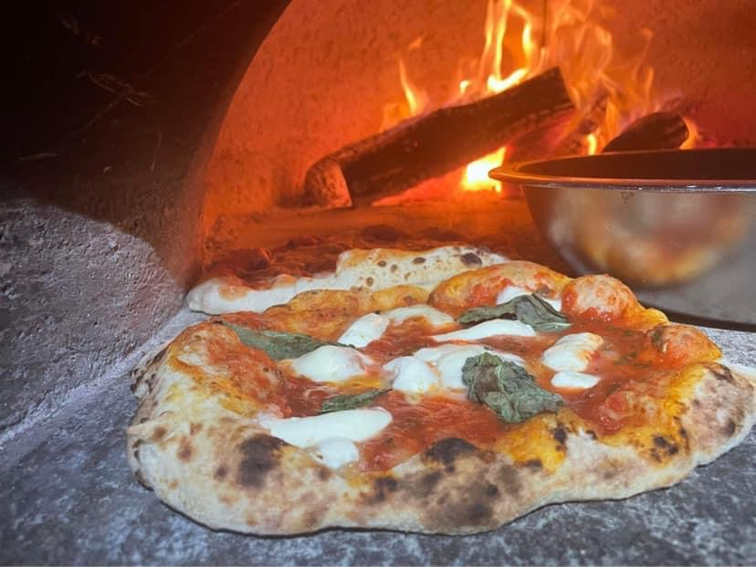

Non Alcoholic Beverage Package - Per Person Cost - (includes plastic cups)
$1pp Sweet Iced Tea, Lemonade. Ice Water.
$2.00 more for canned or 2 Liter Soda includes coolers and ice

Discounts offered for menu packages including items from all three categories.
7% Tax & 20% gratuity added to final cost
⁃ Non profit & school discounts offered
Staffing available for any size event
Upgrade Glass plates, silverware, glassware, linen napkins - starting at $8 dollars per person

